STAFF TIMECARDS

User Tutorial

Accessing Phoenix
TWU Staff Employees may enter and submit timecards and review approval status using Phoenix, TWU Employee Self-Service.
Users will need a Portal account to access Phoenix for timecards.
There are two methods to access Phoenix:
- Double Click on the Phoenix icon on the desktop
- Use Internet Explorer Navigate to the URL: oracle.twu.edu

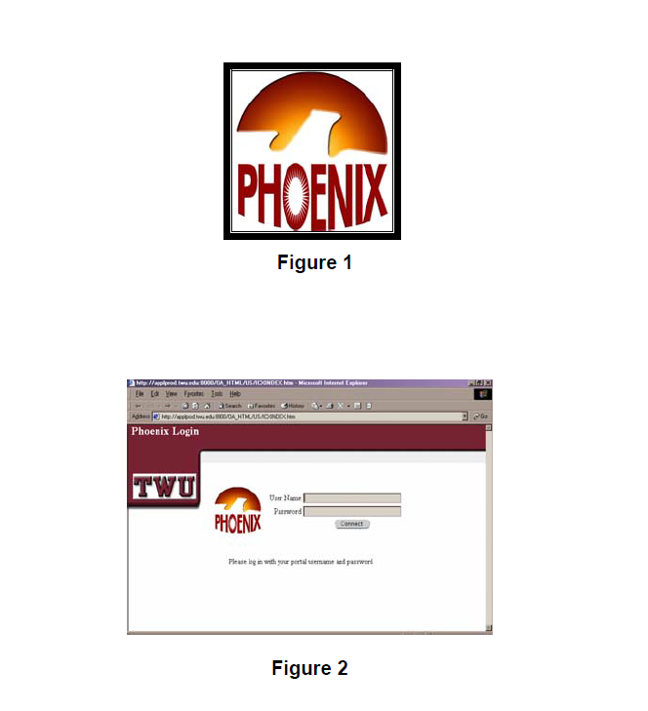

Logging in to Phoenix

Fill in the Portal username and password and click on Connect.

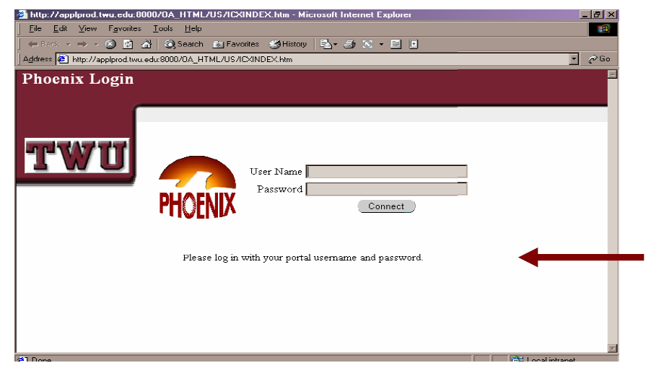

The main menu of Phoenix will appear. Each user’s screen may look slightly different based on roles and responsibilities within the system.

Click on the TWU Employee Self-Service link.

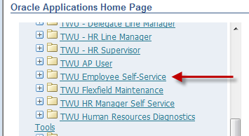
Click on Timecard Entry

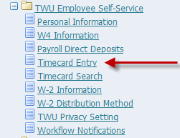

Click on the Create Timecard button. If a timecard is already created for the month, click in the Update field to make updates to the timecard for the appropriate time period.

Update a timecard:

Entering and Editing Timecard Data

The timecard will appear. Be sure to verify the dates in the box labeled Period are accurate. To choose a different time period, Click on the down arrow in the drop down box.
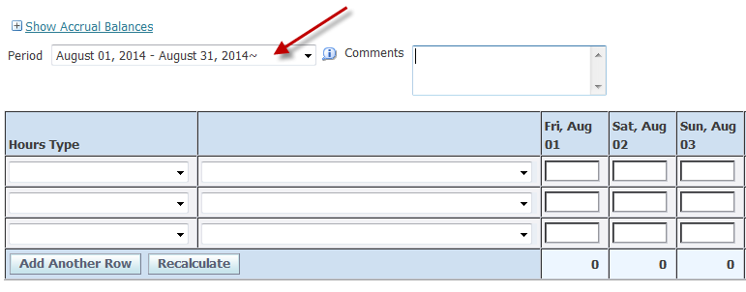
There will be two columns with drop down boxes.
The column on the left side is labeled Hours Type (Regular Hours Worked, Sick, etc.)
The column on the right side is an optional field used in conjunction with sick time taken or for FMLA purposes.
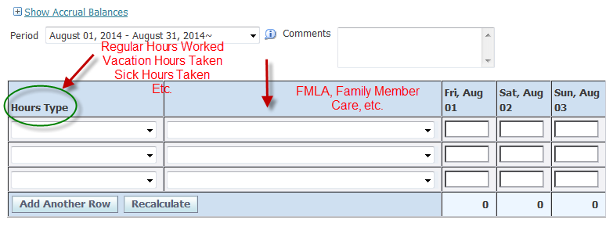
Employees may view their current leave balances directly through the timecard entry area. Click on the link Show Accrual Balances in the upper left hand corner of the timecard entry area.
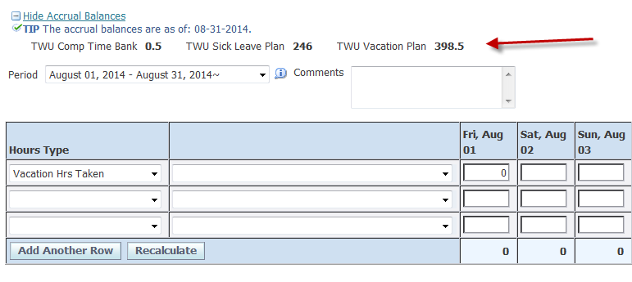
Click on the drop down arrow in the box under the column heading Hours Type. Choose the first type of hours needing to be entered.
The days of the month are organized horizontally from left to right across the screen. Enter the total hours to be recorded under each date for the hours type selected for that line.
NOTE: Exempt employees will only record leave hours. Non-exempt employees will record Regular Hours Worked, Lunch Hours Taken as well as leave hours.
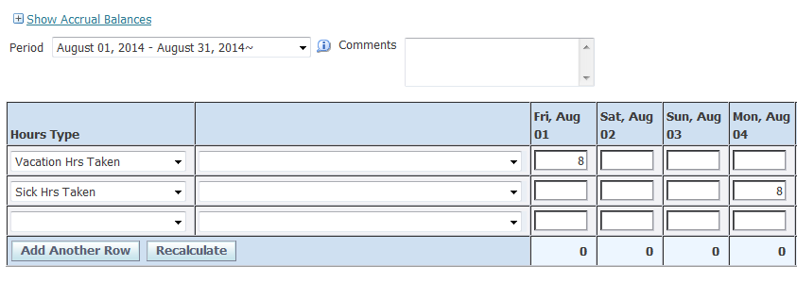
Important Reminders

- Vacation Leave for employees with no prior Texas state service will be available to use after 6 continuous months of state service.

- If all leave balances have been exhausted, please record LWOP Hours Taken on your timecard (Leave Without Pay).

- Remember to record Holiday Hrs Taken for holiday time off. Record Holiday Hrs Worked if you work on a holiday. (Comp time will accrue for the holiday hours worked)

- Exempt employees who do not use any leave time or have any holidays during the month, should still complete a timecard using an hours type label and record a 0 in the first box.
- Timecards must be submitted within five (5) working days and approved within ten (10) working days.

- If a correction is needed to a timecard already submitted, simply click on the update icon and make the necessary change(s). Save the timecard and choose Continue to resubmit the timecard for approval.

Saving, Reviewing and Submitting Timecards
Saving:
To save entries made on a timecard Click on the Save link located above or below the timecard.
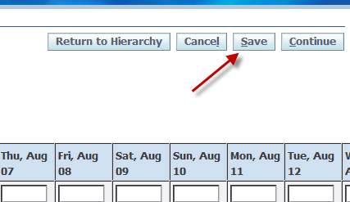
Reviewing:
Click on the Continue link to review your timecard entries.
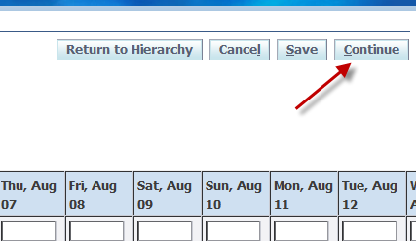

The Review screen will display the summary information for the Timecard.
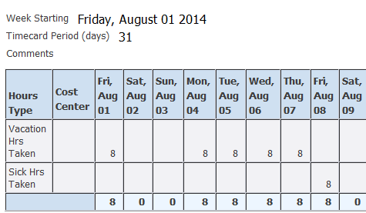
Submitting:
To submit the timecard for supervisor approval, click on the Submit button on the timecard Review page. A confirmation message will appear.
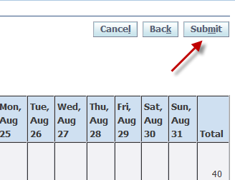
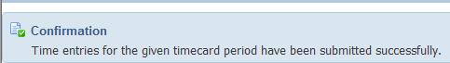

Reviewing Timecard Status
Click on TWU Employee Self-Service, Timecard Entry to view a listing of your timecards with a current status. There are 4 timecard statuses:
- Working
- Submitted
- Rejected
- Approved

- Working – The timecard is in the employee’s queue for entry and not yet submitted for approval.

- Submitted – The timecard has been submitted to your supervisor but not yet approved.

- Rejected – The timecard has been rejected by the employee’s supervisor for correction. If no comments are included with the rejection, please contact your supervisor for further instruction.

- Approved – The timecard has been approved and forwarded to Payroll for posting.

