Viewing your W-2 electronically is available on TWU campus computers only.
Instructions for Accessing W-2 Form

Log into Phoenix:

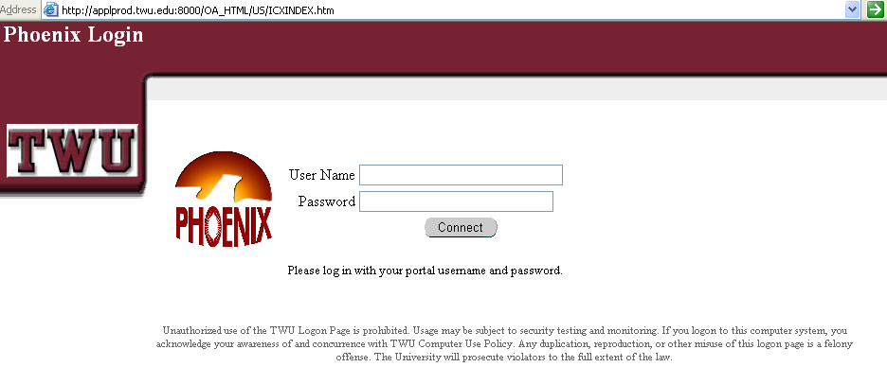

Enter your user name and password in the appropriate fields.

Click on the button.

Student Employees

Student employees who have been assigned only the TWU Student Self Service responsibility in Phoenix will be taken to their W-2. If you are a student employee who has more than one Phoenix responsibility, please select TWU Student Self Service responsibility.

Staff and Faculty

Staff and/or Faculty who have been assigned only the TWU Self Service responsibility will be taken to the TWU Self Service navigator shown below:

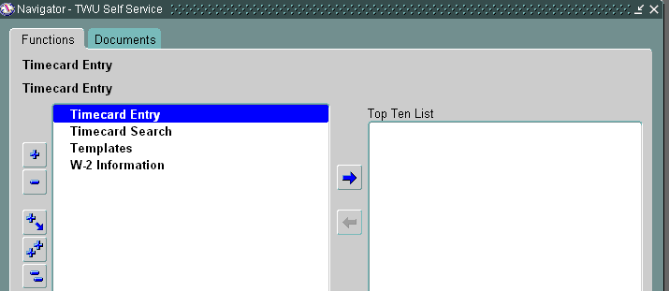
Click Here
Staff and/or faculty with more than one Phoenix responsibility, should select the TWU Self Service responsibility from their navigator.

Select ‘W-2 Information’ to access your W-2. The 2006 W-2 will default; however, should you need to select past year W-2s for any reason, you may select them from the drop down list to the right of the ‘Select Organization/Year’ field, and clicking on the ‘Go’ button:
Change Year Here

Click Here

The toolbar above the W-2 allows you to save a copy and/or print a copy. Should you wish to print the W-2, select the printer icon:
Prints W-2

